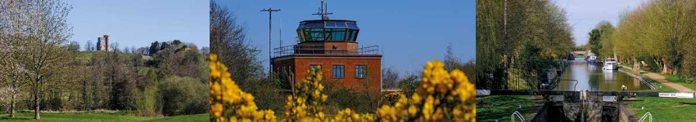

# Council Report for February 2025

### Written by your local Conservative team to keep you up to date.

### Councillor Clive Hooker, Downlands Ward

## West Berkshire Council

#### Council

Council met on 27 February to discuss:

* Medium-Term Financial Strategy 2025/26 - 2028/29 (C4633)
* Investment and Borrowing Strategy Financial Year 2025/26 (C4634)
* Capital Strategy - Financial Years 2025/26 - 2028/29 (C4632)
* Revenue Budget: 2025/26 (C4631)

Papers and a recording of the meeting can be found [here](https://decisionmaking.westberks.gov.uk/ieListMeetings.aspx?CId=116&Year=0).

The next meeting is on 27 March.

#### Executive

Executive met on 13 February to discuss:

* Medium-Term Financial Strategy 2025/26 - 2028/29 (C4633)
* Investment and Borrowing Strategy Financial Year 2025/26 (C4634)
* Capital Strategy - Financial Years 2025/26 - 2028/29 (C4632)
* Revenue Budget: 2025/26 (C4631)
* Capital Financing Report Financial Year 2024/25 Quarter Three (EX4515)
* 2024/25 Revenue Financial Performance Quarter Three (EX4516)
* Devolution and Local Government Reorganisation (EX4659)
* Companion Bus Passes (EX4642)
* Response to the Scrutiny Commission Task and Finish Group Report on Covid and Recovery (EX4638)
* Carers Strategy 2025-2028 (EX4617)
* Bespoke Full-Time Educational Provision for Pupils with SEMH needs who have EHC Plans (13-19 years) (EX4656)

Papers and a recording of the meeting can be found [here](https://decisionmaking.westberks.gov.uk/ieListMeetings.aspx?CId=117&Year=0).

The next meeting is on 3 April.

#### Budget

##### Budget Passed for the next year

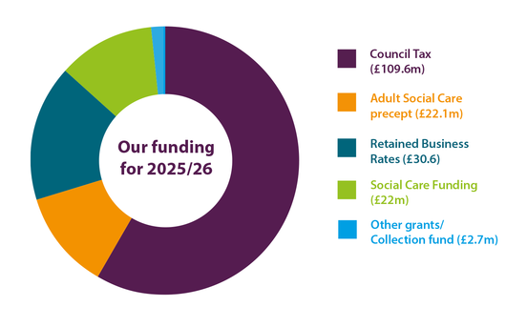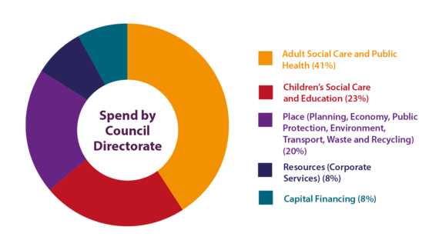

WBC’s spending plans for 2025/26 have been unveiled - setting out how WBC will spend £187m delivering services across the district and £73m on capital projects.

The plans contain a range of commitments focussing on the delivery of core infrastructure across the district, enhancing schools and other education facilities and developing provision for pupils with Special Educational Needs and Disabilities (SEND).

The capital programme will see £73m invested in the district to deliver infrastructure improvements.

##### Capital Budget

A £73m capital programme will see projects delivered across the district, including:

* £18.6m delivering a new solar farm at Grazeley
* Improvements to local roads and pavements including:
  + £12m on highway improvements
  + £400,000 on pavement improvements
  + £300,000 on bridge maintenance projects
* Improvements to local schools including:
  + £2.3m replacing eight classrooms at Falkland Primary School which are currently in old, pre-fabricated modular buildings
  + £1m providing two additional classrooms at Brookfields School
  + £886,000 on four new classrooms at The Castle School
* £2.4m on a nutrient neutrality programme to develop and deliver projects to reduce the nutrients entering the River Lambourn
* £50,000 to provide real-time passenger information and other public transport infrastructure

##### Exceptional Financial Support Requested

WBC has been successful in its request to HM Government for Exceptional Financial Support (EFS).

A letter was sent in January 2025 to request an emergency bailout of £16m, with the budget papers showing they urgently need support or they will need to issue a s114 notice, the Council equivalent of bankruptcy.

The Ministry for Housing, Communities and Local Government has now confirmed that the request has been granted.

The Exceptional Financial Support will be allocated to the Council's year end 2024/25 general reserve fund and to support the 2025/26 budget.

#### Local Government Reorganisation

##### West Berkshire considers options for a new unitary authority

WBC have started discussions with neighbouring local authorities to inform proposals on the future of councils in the area.

It follows an announcement by HM Government in December that will see two-tier councils (county and district councils) abolished and replaced by unitary authorities. It will also look for unitary authorities to provide services for a population of around 500,000 people. With West Berkshire Council - already a unitary authority - covering around 170,000 residents, this means the Government will be looking for us to join with other councils.

Councillors and council officers are currently in discussions with South Oxfordshire and Vale of White Horse District Councils, and the other five Berkshire unitary authorities, to look at different options to deliver local government reorganisation. These discussions have included the possibility of a new unitary council combining West Berkshire, South Oxfordshire and the Vale of White Horse, and exploring options for unitary councils within the county of Berkshire.

Initial proposals must be submitted by 21 March, 2025 with final plans required by 28 November, 2025.

#### Education

##### Revamped outside space at Keevill Unit officially open

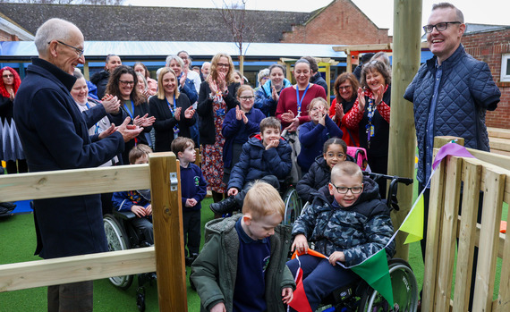The newly revamped outside space at the Keevill Unit at Speenhamland School, Newbury was officially opened by former student Andy Stevenson last week.

WBC provided funding to enable the school to build the outdoor space project which includes a sensory outdoor class, wheelchair-friendly track and 'story throne' area.

Andy was part of the Keevill Unit between 1985 and 1992. He has gone on to work as a TV Presenter and Radio Reporter, including covering the Paris Olympics and Paralympics for BBC TV and American broadcaster NBC.

##### New classrooms for Castle School, Newbury

Work is underway on a brilliant £2.6m project at the Castle School, Newbury that will provide thirty-two new places for pupils aged 2-19 with Special Educational Needs and Disabilities (SEND), many of whom also have physical disabilities and sensory needs.

The project, which was given planning approval in July 2024 will provide four new classrooms with break-out and small group rooms and associated welfare facilities, including a full wet-room. It will be sustainably heated via Air Source Heat Pumps and has been designed to meet BREEAM 'Excellent' in line with the Council's Zero Carbon 2030 targets.

EW Beard Construction has begun preparing the site for the build which is due for completion by early December 2025. Specialist equipment will be fitted ready for the first students in early January 2026.

#### Leisure and Culture

##### New play equipment for Calcot

A new free-to-use Big Rig, cardio combo and resistance shoulder press has been installed by Tilehurst Parish Council at the recreation ground in Calcot.

The equipment, which cost around £20,000, was paid for in part by West Berkshire Council’s Community Infrastructure Levy Fund (CIL) – a charge paid by developers which goes towards local infrastructure. It was match funded by Tilehurst Parish Council.

Similar equipment installed at Turnham’s Farm recreation ground in 2023 has been well used by a wide range of ages and abilities - and has prompted similar equipment to be installed at Calcot.

#### Environment

##### Project Groundwater Innovation Fund opens

Funded by Project Groundwater, the Innovation Fund is dedicated to empowering local communities to address groundwater flooding, funding projects that seek to improve flood resilience in West Berkshire.

Residents can apply for up to £20,000 to support the local community in flood resilience schemes.

More information is available [here](https://www.projectgroundwater.co.uk/)

#### Community

##### Fire and rescue service recruiting for summer internship

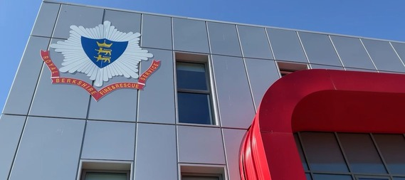Royal Berkshire Fire and Rescue Service is now accepting applications from young people in Berkshire to join the service’s Summer Internship Scheme.

The internship aims to encourage 18-year-olds from backgrounds that are underrepresented within the service to explore some of the many roles available to them in the fire and rescue sector.

Each intern will have the opportunity to gain valuable real-world work experience and transferable skills working alongside teams within the Service. During the scheme, the interns will participate in learning and development workshops, as well as visits to several fire stations across Berkshire.

The service is looking for four interns to join the scheme for five weeks in the summer, from Thursday, 4 July to Friday, 9 August. As part of the internship, each successful applicant will be paid an hourly wage of £10.66.

##### Fire and Rescue Service safe and well visits

Royal Berkshire Fire and Rescue Service (RBFRS) want to check in on people who may struggle to get out of their home in an emergency.

When a smoke alarm goes off, most people can get out of their homes and call 999. Most, but not all.

Can you think of anyone that doesn’t have an alarm, might not react to an alarm, or can’t easily evacuate their home if their smoke alarm was to activate?

If the answer to any of those questions is yes, please [visit the RBFRS website](https://www.rbfrs.co.uk/your-safety/safety-at-home/book-a-safe-and-well-visit/) to help keep communities safe. Residents can also call the freephone 0800 587 6679 between 9am and 5pm, Monday to Friday, or use the answerphone available outside of these times.

##### Community groups invited to apply for crime prevention funding



Thames Valley Police and Crime Commissioner Matthew Barber has opened the first round of this year’s Community Fund, with a particular focus on supporting projects that tackle anti-social behaviour and vehicle crime. Community groups are invited to apply for a share of £200,000 of crime prevention funding.

The Community Fund, jointly managed by the Police and Crime Commissioner and Chief Constable at Thames Valley Police, helps to prevent crime and keep communities safe. Money for the scheme is created from the proceeds from the sale of items seized from criminals that cannot be returned to their rightful owners.

The closing date for this round of applications is 12pm (noon) on Monday 24 February.

#### Current Consultations

* There are no current consultations open.

Councillor Clive Hooker

[clive.hooker@westberks.gov.uk](mailto:clive.hooker@westberks.gov.uk)

07798 920981