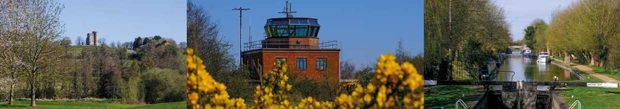

# Council Report for March 2025

### Written by your local Conservative team to keep you up to date.

### Councillor Clive Hooker, Downlands Ward

## West Berkshire Council

#### Council

Council met on 27 March to discuss:

* Hungerford Neighbourhood Development Plan
* Statutory Pay Policy 2025/26
* Constitutional Changes
* Member Development Programme
* Leaders Update on Membership of Executive

Papers and a recording of the meeting can be found [here](https://decisionmaking.westberks.gov.uk/ieListMeetings.aspx?CId=116&Year=0).

There was no meeting of Council this month.

The next meeting is on 1 May (Extraordinary Meeting).

#### Executive

Executive met on 19March to discuss:

* Replacement Finance System Direct Award
* Ridgeway Council

Papers and a recording of the meeting can be found [here](https://decisionmaking.westberks.gov.uk/ieListMeetings.aspx?CId=117&Year=0).

There was no meeting of the Executive this month.

The next meeting is on 3 April.

#### Devolution

##### Ridgeway Council

An initial proposal has been submitted on behalf of West Berkshire Council, South Oxfordshire District Council and Vale of White Horse District Council for the creation of a new unitary council that would see the three areas combined. At their Executive and Cabinet meetings last week, members from all three councils agreed to support the submission of the interim proposal. The proposal is being developed under the title 'Ridgeway Council' - named after the famous 5,000-year-old trail that travels through the heart of the three council areas.

The move is in response to a government invitation following its announcement in December 2024 to end two-tier authorities like those in Oxfordshire. As part of the shake-up of local councils, the government has also indicated all unitary authorities will need to serve around 500,000 residents or more, which will require West Berkshire Council - which covers around 170,000 people - to merge with neighbouring councils.

The government has set a deadline for final submissions for unitary council proposals no later than 28 November 2025. In the meantime, the councils will continue to develop the proposals along with a programme of communication and engagement to ensure local voices and community needs are reflected in the [proposal](https://www.westberks.gov.uk/article/43926/Introducing-Ridgeway-Council-part-of-a-two-unitary-council-option-for-Oxfordshire-and-West-Berkshire).

The Leader of Reading Borough Council, and the MP for Reading West and Mid Berkshire, have expressed the view that eastern parts of West Berkshire Council should be moved into Reading. HM Government is yet to publish its response to the proposal, which should be released soon.

#### Culture

##### Shaw House Tudor Garden now open

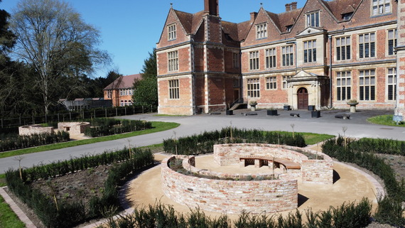The work on the Tudor Garden at Shaw House is now complete. The project, led by West Berkshire Council's Community Services was made possible through funding from the UK Shared Prosperity Fund.

Designed by horticulturist and designer, Andrea Fearon from Ivy Hill Garden Design, this unique community space has been created with relaxation in mind and is perfectly placed to enjoy views of Shaw House.

Andrea kindly volunteered her time to construct the garden with a thoughtful approach to the historic setting, the environment and local wildlife. While the plants are all true to a Tudor period garden, the style in which they have been planted offers a contemporary interpretation; with ornamentals, herbs and vegetables being mixed in the borders rather than separated into dedicated spaces.

The garden is now open for visitors to enjoy, but as the planting took place during the winter months, it may be best to return during the summer months to see the garden in full bloom. Shaw House is open to the public every weekend 11am – 4pm until the end of September, and Monday to Friday 10am – 4pm during school holidays.

##### Talk: The archaeology of Compton

The Domesday settlement of Compton is referred to as two places, Westcumpton and Estcumpton from 1241. East Compton was the area around St Mary and St Nicholas’ Church, and West Compton was the larger hamlet despite formerly been called Compton Parva, meaning minor or little!

Find out more and meet members of West Berkshire Council’s Archaeology team as they delve into the parish’s historic environment and share some of the fascinating artefacts found there by members of the public.

West Berkshire Museum | Wednesday 23 April | 7pm | [£5](https://booking.westberks.gov.uk/heritage_events.html?event_id=2410040&companyId=37003)

##### Northcroft Lido open for 2025

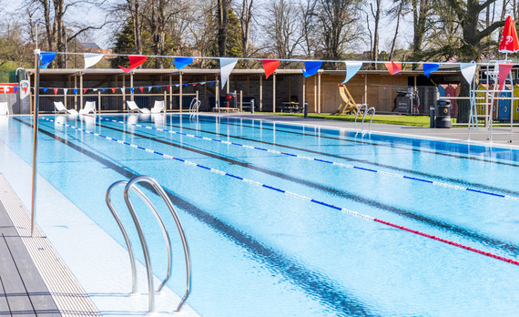Northcroft Lido reopened its doors for swimmers to jump into the 2025 Spring/Summer season from 2 April.

The heated, Olympic-length pool is ideal for some ‘al fresco’ lane swimming during the spring and summer months, while the interactive splash pad and 6-metre spiral flume offers the perfect opportunity for families and friends to have fun in the water. Outdoor swimmers and families can also enjoy the popular decking area of the lido where people can relax next to colourful beach huts that create a seaside feel.

The iconic 150-year-old outdoor facility underwent a £5million refurbishment in 2023 to provide an enhanced experience and its popularity among locals continues to rise.

Open until the end of September, Northcroft Lido will be hosting a variety of events over spring and summer. Visitor numbers are limited, and booking is essential to avoid disappointment. Under 8s must be accompanied by an adult.

##### 3G pitch coming to Cotswold Sports Centre

A 3G artificial playing pitch will be installed at the Cotswold Sports Centre in Tilehurst.

Funded by the UK Shared Prosperity Fund, the project will redevelop the multi-sport courts situated behind the sports centre.

The development will include a 3G surface with suitable fencing and goals to be primarily used for football, although the space will be available for residents to book and use for a range of sports.

The new pitch will be the same size as the existing courts, allowing for small-sided match play and will be used for a mix of social and formal sport for local clubs and teams to book as a training space, but also for parties and activities.

As part of the sports centre offering, Everyone Active will run an exciting and varied programme at the facility, on behalf of West Berkshire Council. Work starts in Spring for completion early Summer.

##### Goodbye to the Mobile Library

There has been a mobile library service in this district for at least the past 40 years and at the height of its popularity there were three library vehicles operating in West Berkshire. Over the years, staff have been there for residents in rural areas, offering books, advice and friendly words to their customers who waited regularly for the Mobile Library to arrive throughout all seasons.

Due to diminishing numbers of customers using this service in recent years and the fact that the one remaining vehicle had reached the end of its working life, WBC said goodbye to the Mobile Library at the end of March 2025. Without doubt, fond memories of the service will remain for many years to come.

###### Looking Forward

Although the Mobile Library will be missed, West Berkshire Libraries will continue to work hard to bring books to those who can’t get to their local library and serve customers in rural and isolated areas:

###### At Home Library Service

For instance, for residents who find it difficult to visit their local library because of age, disability, lack of access to transport or caring responsibilities, WBC will bring the library service to them. They will match each person with a DBS-checked library volunteer, who will find out about their reading tastes and then choose and deliver books to them at their home every three weeks at a pre-arranged time.  Favourite authors or particular titles can be requested.  Please ring 01635 519827 or email [library@westberks.gov.uk](mailto:library@westberks.gov.uk) to find out more.

###### Pop-up Libraries and Community Bookshelves

WBC are also working with town and parish councils to set up regular pop-up libraries and community bookshelves at locations of their choice, according to local need; and are delighted to link in with existing events such as village hall coffee mornings and community cafes. Pre-ordered book reservations can be dropped off to residents at these locations at a time to suit the local community.

#### Environment

##### GreenFest Newbury

Saturday 5 April, 10:30 AM – 3 PM, St Bartholomew’s School, Newbury, RG14 6JP

Join GreenFest Newbury for a free day of sustainability, advice, talks, crafts, stalls and creativity! GreenFest 2025 will inspire, educate, and enthuse with engaging stalls, free hands-on activities, fascinating free talks by experts in their field, as well as delicious food & drink vendors, and great music from Kennet Radio.

Entry, all activities, and talks are free and suitable for all the family.

What’s going on…

**🌱 Food Zone** – Enjoy fresh, local produce, compost demos, seed sowing, rewilding projects, vegan recipes, and eco-friendly finds! 🍓🌍

**🏡 Home Zone** – Learn energy-saving tips, explore renewables, and grab eco-friendly freebies! 🌞💡

**🚗 Travel Zone** – Bust the EV myths and discover sustainable travel tips! ⚡️🌱

**🐾 Nature Zone** – Explore wildlife gardening, plant swaps, apple pruning, and local projects. Plus, enjoy wildlife photography and fundraising merch! 🌳🍏

**💚 Community Zone** – Join drumming lessons, climate campaigns, arts for activism, tree planting, and DIY bird feeders! 🥁🌧️

**🛍️ Stuff Zone** – Learn about ESG, refillable products, Kintsugi repairing, knitting, and rock painting! ♻️🎨

Full list of GreenFest FREE talks [here](https://www.wbge.org.uk/greenfest-824659-858205.html)

West Berkshire Council officers will be attending GreenFest to support this event, and will be on hand offering waste and recycling advice, guidance on EV charging, plus, sustainable transport and energy options. Some of the West Berkshire Council teams represented at the event include Waste Management, Transport and Highways among others.

#### Transport

##### Cycle signs keeping you on the right path

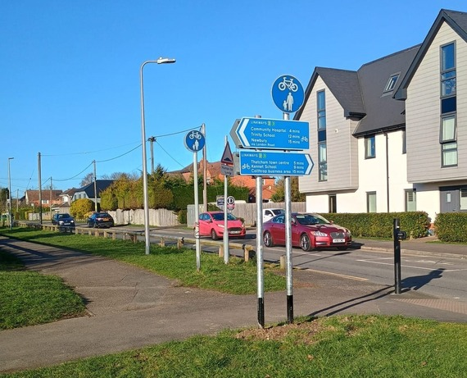West Berkshire Council has installed new cycle direction signs between Newbury and Thatcham town centres.

The new signs have the local ‘Linkways’ branding, which is gradually being rolled out to identify main routes for cycling.

The signs also show average cycling time in minutes to destinations such as the Nature Discovery Centre.

Encouraging and enabling active travel fits with the Council Strategy Priority of tackling the Climate and Ecological emergency, by offering many residents an alternative for some or all of their local, shorter-distance journeys.

##### Talk: A hundred years and more of cycle clubs in Newbury

Newbury Road Club will be celebrating its centenary in 2025, but cycle clubs have been busy in Newbury for many more years. This talk will give a short history of cycling clubs in Newbury with particular emphasis on the Newbury Road Club from its formation by the Bance brothers to the active and busy club it is today.

West Berkshire Museum | Wednesday 23 April | 1pm | [Free](https://booking.westberks.gov.uk/heritage_events.html?event_id=2656991&companyId=37003)

#### Current Consultations

* [**Berkshire Digital Infrastructure Group (DIG): Residents' Survey 2025** – Closes 16 April 2025](https://westberks.gov.uk/residents-survey-on-digital-2025)
* [**Proposal to introduce a new Public Spaces Protection Order (PSPO) in Pangbourne Meadows** – Closes 30 April 2025](https://westberks.gov.uk/pspo-pangbourne-meadows)
* [**Draft Hackney Carriage and Private Hire Licensing Policy 2025-2030** – 18 May 2025](https://westberks.gov.uk/draft-taxi-policy-2025)
* [**Springfield Primary School - School Streets Scheme** – Closes 18 May 2025](https://westberks.gov.uk/draft-taxi-policy-2025)

***Councillor Clive Hooker***

***Ward Member, Downlands***

***Vice Chairman Western Area Planning Committee***

***Tel: 07798 920981***

***Email:*** [***Clive.Hooker@westberks.gov.uk***](mailto:Clive.Hooker@westberks.gov.uk)