**Guide to accessing Early Intervention Support Funding**

Early Intervention Support Funding (EISF) is the process West Berkshire will use to allocate High Needs Block Funding to support schools with pupils who do not have an Education, Health and Care Plan (EHCP) but have significant additional needs beyond those that might be expected to be funded from the SEND Notional Budget. This funding is intended to provide short-term additional support to help close the gap for statutory school aged children with needs that exceed what would ordinarily be expected at SEN support.

It replaces existing mechanisms in different services, providing one route for referral and decision making, and supporting a fair and transparent allocation system.

Children and young people (CYP) might experience the following challenges:

* Have experienced school moves due to their additional needs that is impacting on learning and progress.
* Be on reduced hours or not attending where additional support is required to extend hours or support attendance, engagement and reintegration.
* Where previous setting has had SENIF funding to support a child and new setting needs continuation to support transition into school short term.

* Experience difficulty in making sufficient progress towards their outcomes due to EBSA (where a detailed plan to support meeting needs is evidenced).

* Have experienced long term medical absence and are returning to school.

* Require support beyond quality first teaching and school-based support and intervention, as set out in the Ordinarily Available Provision (OAP) Guidance *(in production)* but may not need an Education Health and Care Assessment at this time.

* Have had experienced an unexpected or sudden change that significantly impacts their learning and behavioural presentation, but with appropriate intervention, can close the gap.

* Have a medical condition that affects their learning and is creating a gap that can be closed with additional support that is above OAP.

* A risk assessment which evidences danger to self and others and school requires additional support to prevent suspension or permanent exclusion.

Any requests for funding for children in care should be discussed with the child's virtual school consultant. Please refer to specific pupil premium plus guidance for children in care: <https://www.westberks.gov.uk/article/43199/The-Virtual-School-Pupil-Premium-Plus>

**Accessing Early Intervention Support Funding (EISF)**

The following criteria **must** be adhered to.

The Child/Young Person **must:**

* Have significant barriers to learning which require support over and above what is considered ‘Ordinarily Available’ and thus incurs costs which are over and above any SEND notional budget
* Be accessing a Mainstream School within West Berkshire
* Be **on roll** and regularly attending the educational setting, which is making the application, or has been identified as experiencing EBSA, where funding support is required to support reintegration.

The Child/Young Person **must not:**

* Have an existing EHCP
* Be in receipt of other funds e.g. that available for pupils who have arrived new in country
* Be a child in care.

**Applying for Early Intervention Support Funding (EISF)**

Schools must use this form:  INSERT LINK

In which they must clearly evidence the support they have provided and the impact of this. Where the child has moved from another school, the school can provide evidence from the previous school.

In exceptional circumstances, new information (following submission) will be considered to exemplify higher needs. It is expected that conversations will be had with lead professionals prior to panel in such exceptional circumstances.

The West Berkshire OAP Guidance *(in development)* will provide examples of the range of support that might be in place for children and young people at SEND Support, and you may find it helpful to draw from this in evidencing what you have  provided and its impact. Where an external agency has been involved, you should evidence how you have implemented their recommendations. Professionals could include Educational Psychologists, LA commissioned outreach from special schools or specialist provisions, or an advisory team or therapist.

This funding is short term, and the application must clearly evidence an exit strategy for when the funding ceases.

Please note that there is a maximum of two applications per child / young person within a 2-academic-year period.  Please be advised that second application will not be considered until an evaluation of the impact of funding has been submitted.

Applications will be evaluated monthly by a multi-disciplinary panel. Termly Panel dates will be shared at the beginning of each term. Submission to a panel will need to be made 2 weeks before the panel date.  This schedule ensures that the panel has sufficient time to convene, make decisions, and process payments efficiently. Typically, a maximum of 8 applications will be reviewed per month. New applications will be put on subsequent panels once maximum is reached.

The panel will review the applications, considering the following information and documents, as applicable. Schools will be notified of the outcome within 1 week of the panel meeting.

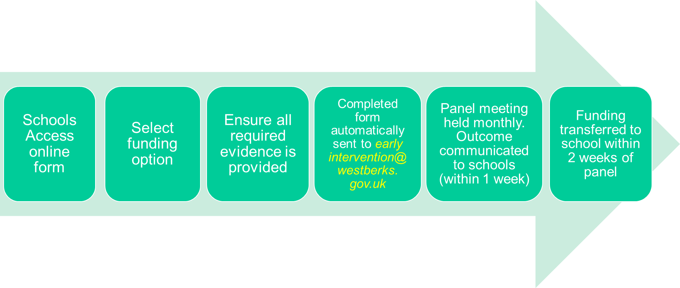

**All applications must include:**

* A person-centred West Berks ‘Support and Achievement Plan’ (or similar documentation including sections listed in West Berkshire’s My Support Plan) in place. With clear evidence of the plan, do, review and assess cycle being implemented, interventions being evaluated and adjusted if not having impact.
* Ensure there is a **minimum of 1 cycle** of ‘Assess, Plan, Do, Review, (APDR) - properly reviewed for impact.

* Child-centred outcomes to be achieved by the end of the funding or intervention period (to be stated on the form).

**Evidence submitted should demonstrate:**

* Implementation of a Graduated Response over time (this may be across more than one school where there have been schools moves).
* Clear evidence of interventions specific to area of need identified within application.
* Involvement of external professionals and evidence of their advice being implemented and evaluated.
* Clear detail of how additional funding will be spent with clear measurable outcomes.
* Clear evidence of the exit strategy to be implemented when funding ceases.
* Documentation must evidence the strategies being implemented by adults (rather than what the pupil is expected to do).
* Evidence that behaviour logs are being evaluated and strategies implemented as a result of information gained from analysis.
* Provision maps should be included if not already clear in the ‘Support and Achievement Plan’ but do not require costings.
* Evidence of how school has used CPD / external support to up-skill all staff in meeting identified need.
* In the case of pupils accepted through the Fair Access Protocol (FAP), documented evidence of need and intervention required to meet identified need including evidence from previous setting (where available) and FAP process.
* If a CYP is on a **reduced/part-time timetable**, this must be made clear as to why this is in place and how the hours are going to be increased and what provision is anticipated to support return to full time education. When a CYP does not attend full time education the funding will be pro-rata in relation to the plan to increase to full time.
* In cases where risk assessment evidences danger to self and others and school requires additional support to prevent suspension, evidence should be provided on how the equality duty has been implemented taking account of SEND needs. This might include support provided and training for staff to prevent recurrence and facilitate successful reintegration.

**Consent:**

The online form must be submitted with a consent form with a physical signature. Please ensure that the parent/guardian and/or CYP is fully aware of and understands what information you intend to share to access the service(s) or funding.

**Funding:**

The funding level allocated out of the two available values will be determined based on need at a maximum of £3,000 for first application and £1,500 for the second application within a 2-year period for the same pupil. This is to ensure that the funds are distributed equitably across the West Berkshire pupil population.

For the second application, there must be a compelling case for why extra funding would close the gap for the child/young person.  An evaluation form: Impact of Early Support Funding (see accompanying document) will then need to be completed to assess the impact and submitted with an updated ‘Support and Achievement Plan’.

If a child or young person moves out of the school, it is the school’s responsibility to inform West Berkshire LA. Additionally, if they leave education, attend alternative provision (AP), or become elective home educated (EHE), funding will end on the date they leave, and schools must notify West Berkshire LA of this.

For group funding applications, please complete section B (School information) and Sections D – F in addition to submitting evidence indicating other interventions previously used.

In exceptional circumstances, where a meeting has taken place with the Exclusions and Reintegration Team, funding can be agreed outside of usual panel processes and timelines, with ratification of decision brought to the next panel meeting.